LAB - 1

1. **Describe IaaS**

Infrastructure as a Service (IaaS) in AWS (Amazon Web Services) is a crucial cloud computing model that delivers virtualized computing resources over the internet. It offers scalable and flexible services, allowing users to manage, monitor, and scale their infrastructure efficiently.

**Benefits of IaaS in AWS**

* **Scalability:** Easily scale resources up or down based on demand.
* **Cost-Effectiveness:** Pay only for the resources you use.
* **Flexibility:** Choose the operating system, programming language, and database.
* **Reliability:** Benefit from AWS's highly reliable and secure global infrastructure.
* **Security:** Utilize robust security measures, including encryption and compliance with various standards.

**Use Cases of IaaS in AWS**

* **Development and Testing:** Quickly set up and tear down environments, saving time and cost.
* **Website Hosting:** Host scalable websites and web applications.
* **Big Data Analysis:** Store and process large datasets efficiently.
* **Backup and Recovery:** Implement solutions to protect data and ensure business continuity.
* **Enterprise IT:** Run enterprise applications and business-critical workloads.

1. **List the Compute and Storage services available in AWS and GCP.**

**AWS (Amazon Web Services)**

**Compute Services**

1. **Amazon EC2 (Elastic Compute Cloud):** Resizable compute capacity in the cloud.
2. **Amazon ECS (Elastic Container Service):** Highly scalable container orchestration service.
3. **Amazon EKS (Elastic Kubernetes Service):** Managed Kubernetes service.
4. **AWS Lambda:** Run code without provisioning or managing servers.
5. **AWS Fargate:** Serverless compute engine for containers.
6. **Amazon Lightsail:** Easy-to-use cloud platform for simpler workloads.
7. **AWS Batch:** Run batch computing workloads.
8. **AWS Outposts:** Run AWS infrastructure on-premises.
9. **AWS Elastic Beanstalk:** Easy deployment and scaling of web applications and services.
10. **AWS App Runner:** Run containerized web apps and APIs at scale.

**Storage Services**

1. **Amazon S3 (Simple Storage Service):** Scalable object storage.
2. **Amazon EBS (Elastic Block Store):** Persistent block storage for EC2 instances.
3. **Amazon EFS (Elastic File System):** Scalable file storage for use with AWS Cloud services.
4. **Amazon FSx:** Fully managed third-party file systems (e.g., Windows File Server, Lustre).
5. **AWS Storage Gateway:** Hybrid cloud storage with local caching.
6. **AWS Backup:** Centralized backup service for AWS and on-premises resources.
7. **Amazon Glacier:** Low-cost cloud storage service for data archiving and long-term backup.
8. **AWS Snow Family:** Physical devices to transfer large amounts of data into and out of AWS.
9. **Amazon S3 Glacier Deep Archive:** Lowest-cost storage class for archiving data.

**GCP (Google Cloud Platform)**

**Compute Services**

1. **Google Compute Engine:** Scalable, high-performance virtual machines.
2. **Google Kubernetes Engine (GKE):** Managed Kubernetes service.
3. **Google App Engine:** Platform-as-a-Service (PaaS) for building scalable web applications.
4. **Google Cloud Functions:** Event-driven serverless compute platform.
5. **Google Cloud Run:** Fully managed compute platform for running containerized applications.
6. **Google Anthos:** Hybrid and multi-cloud application platform.
7. **Google Cloud Batch:** Managed service for running batch jobs.

**Storage Services**

1. **Google Cloud Storage:** Scalable object storage.
2. **Persistent Disk:** High-performance block storage for Compute Engine.
3. **Filestore:** Managed file storage service.
4. **Cloud Storage Transfer Service:** Transfer large amounts of data to Google Cloud Storage.
5. **Cloud Storage Gateway:** Hybrid cloud storage solution.
6. **Cloud Bigtable:** Fully managed, scalable NoSQL database for large analytical and operational workloads.
7. **Cloud SQL:** Fully managed relational database service.
8. **Cloud Spanner:** Horizontally scalable, strongly consistent, relational database service.
9. **Archive Storage:** Low-cost archival storage.
10. **Create 2 Identical AWS EC2 Instances (Instance Name: Regno_EC2_VM1,Regno_EC2_VM2) and install the necessary packages to execute a program of your choice in ‘Regno_EC2_VM1’.**

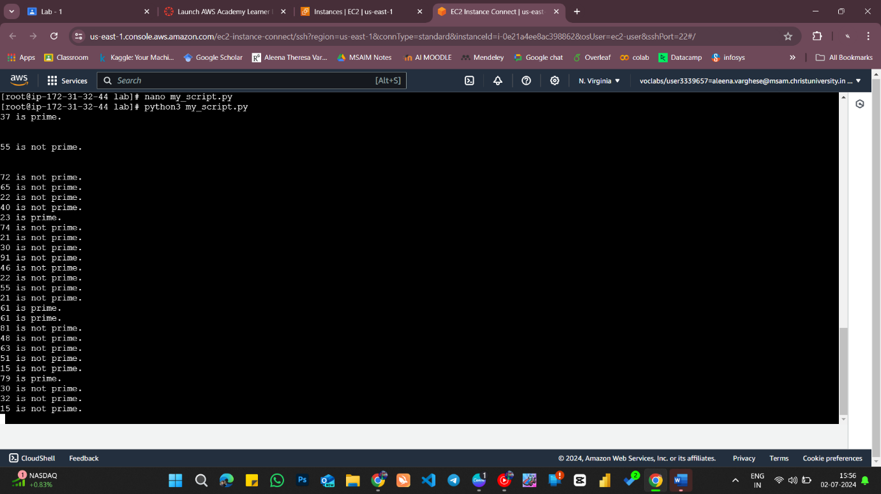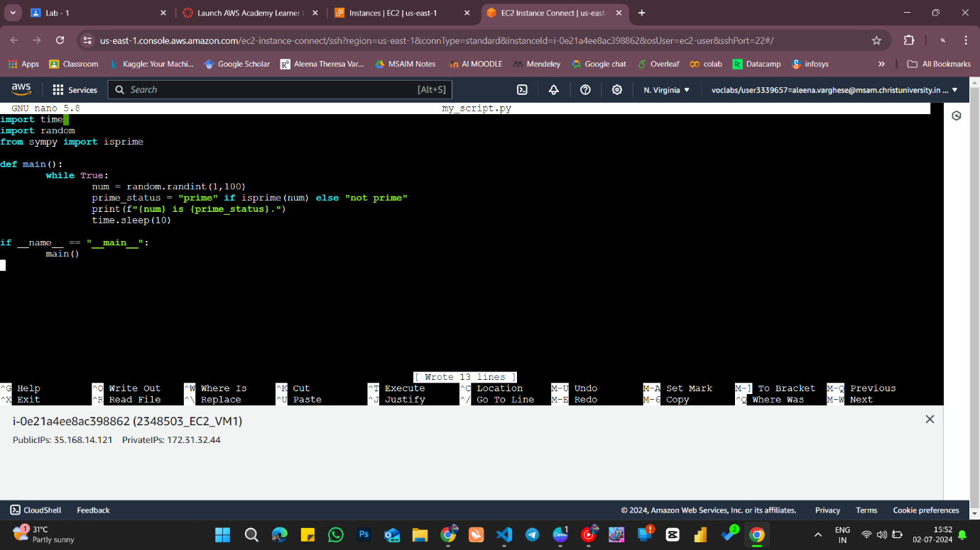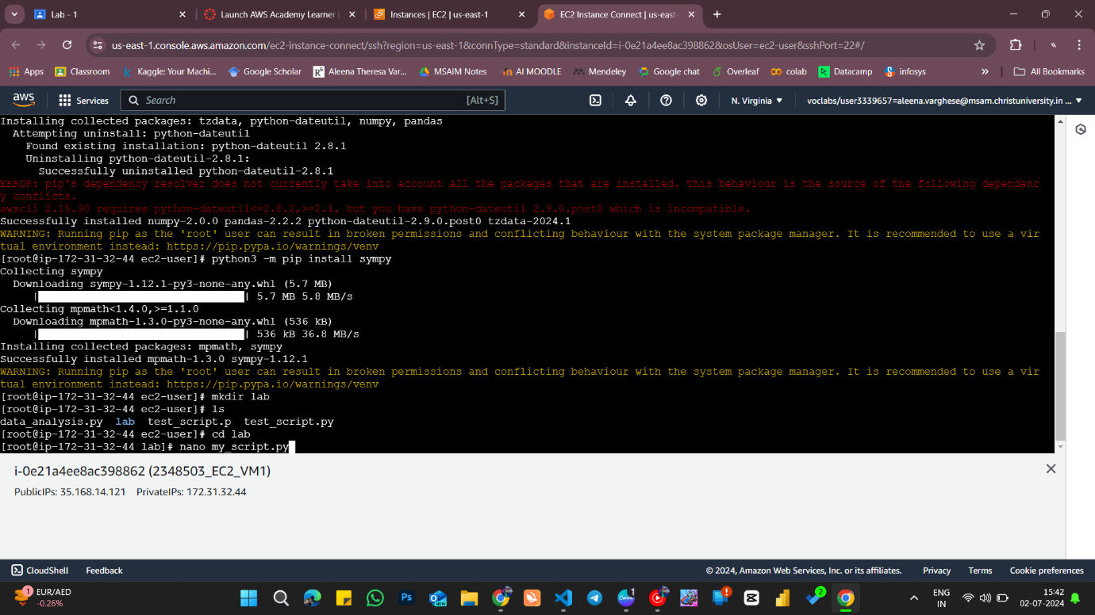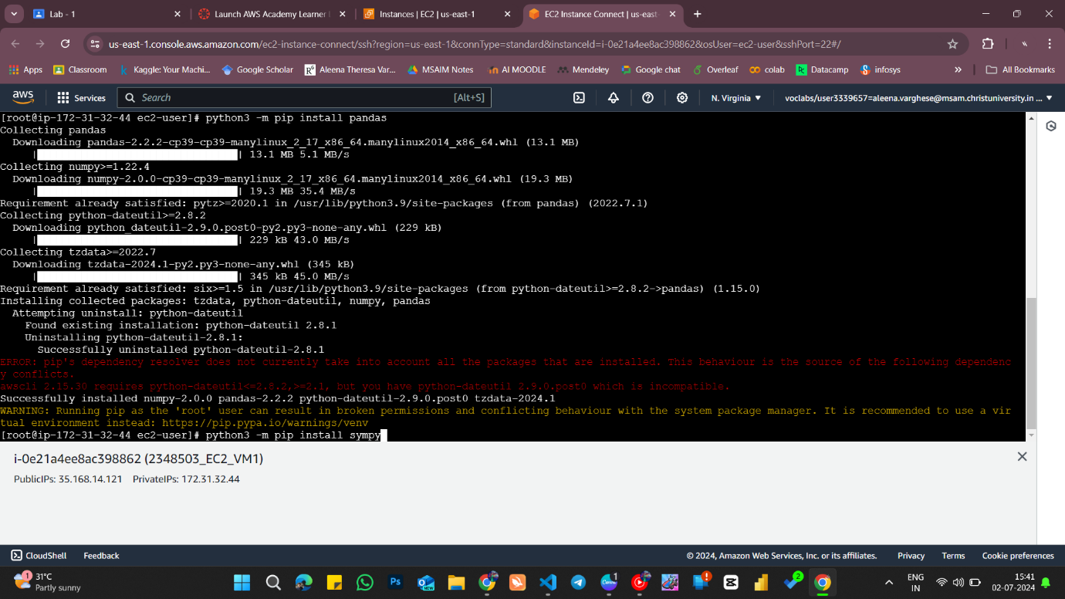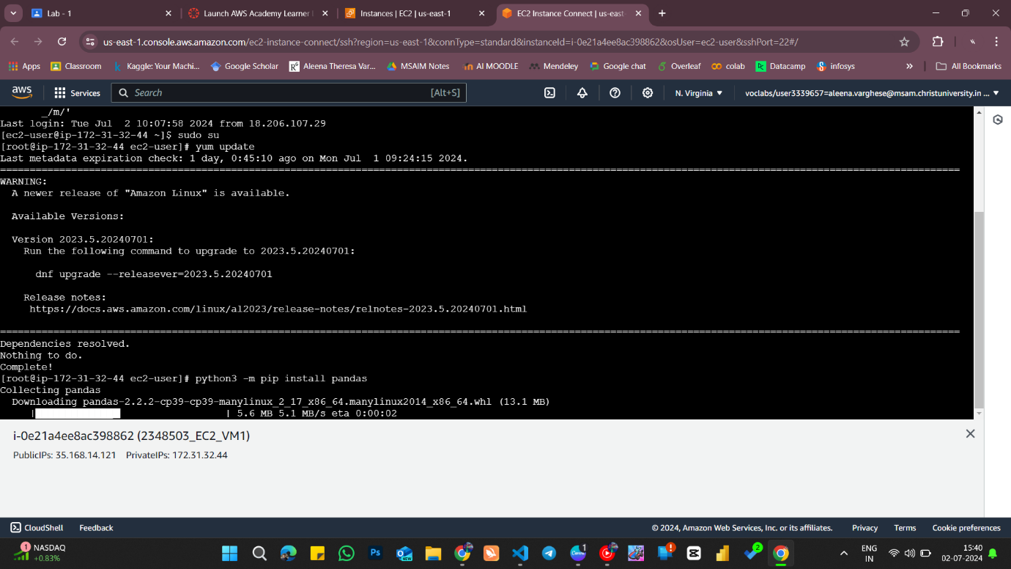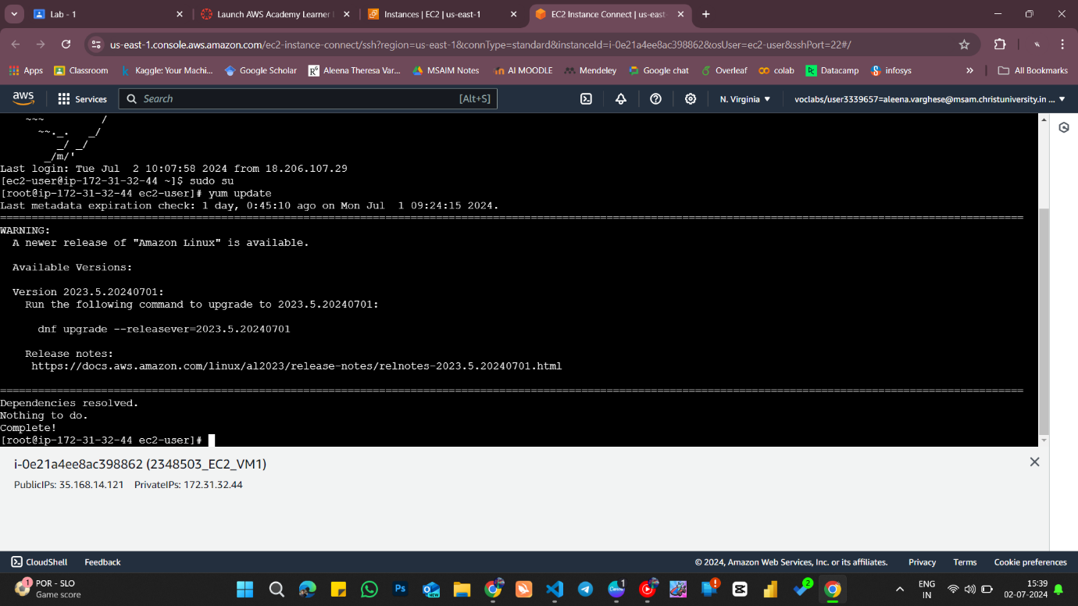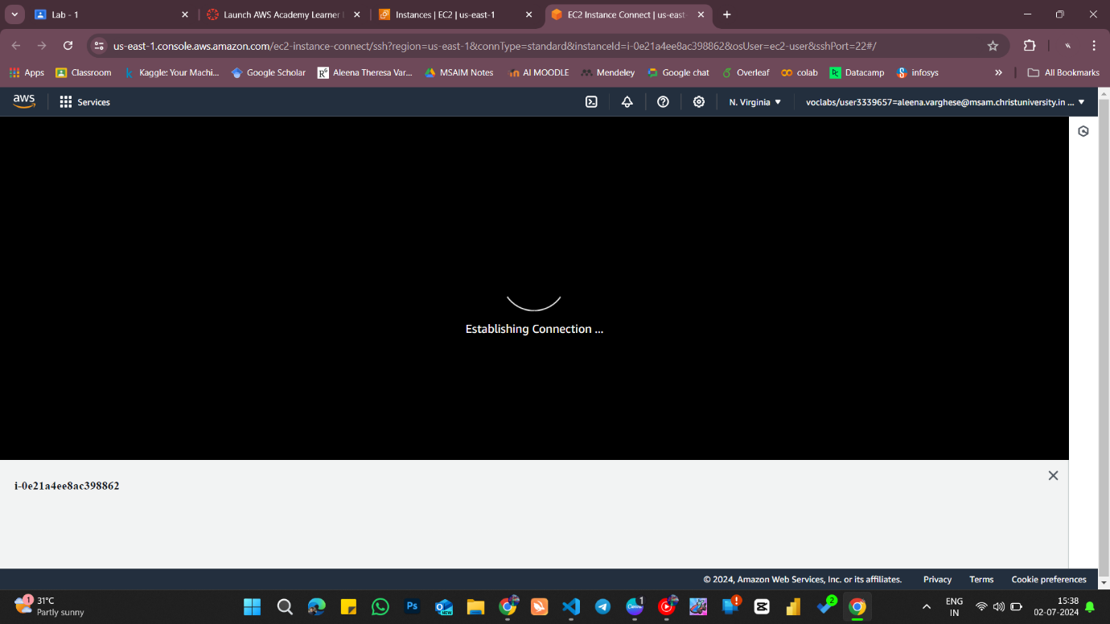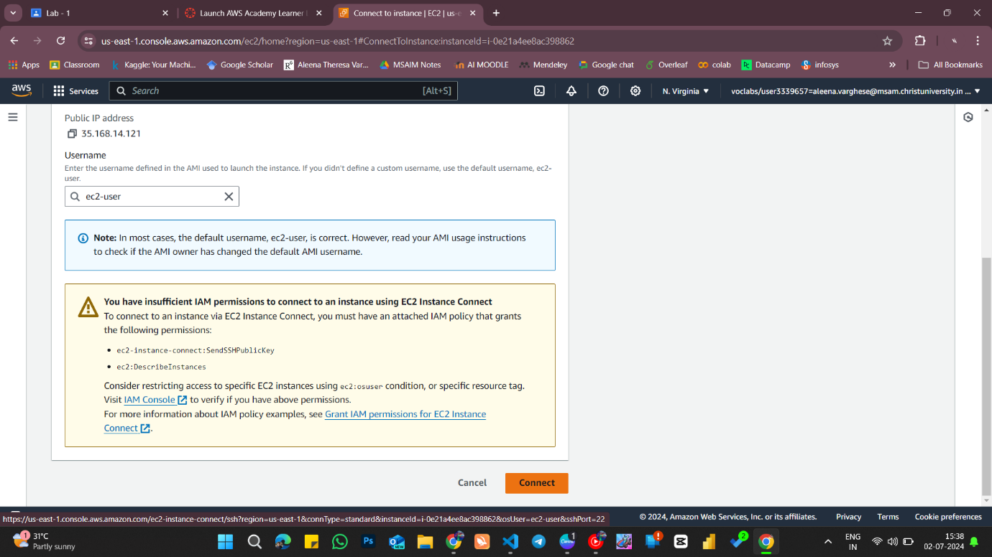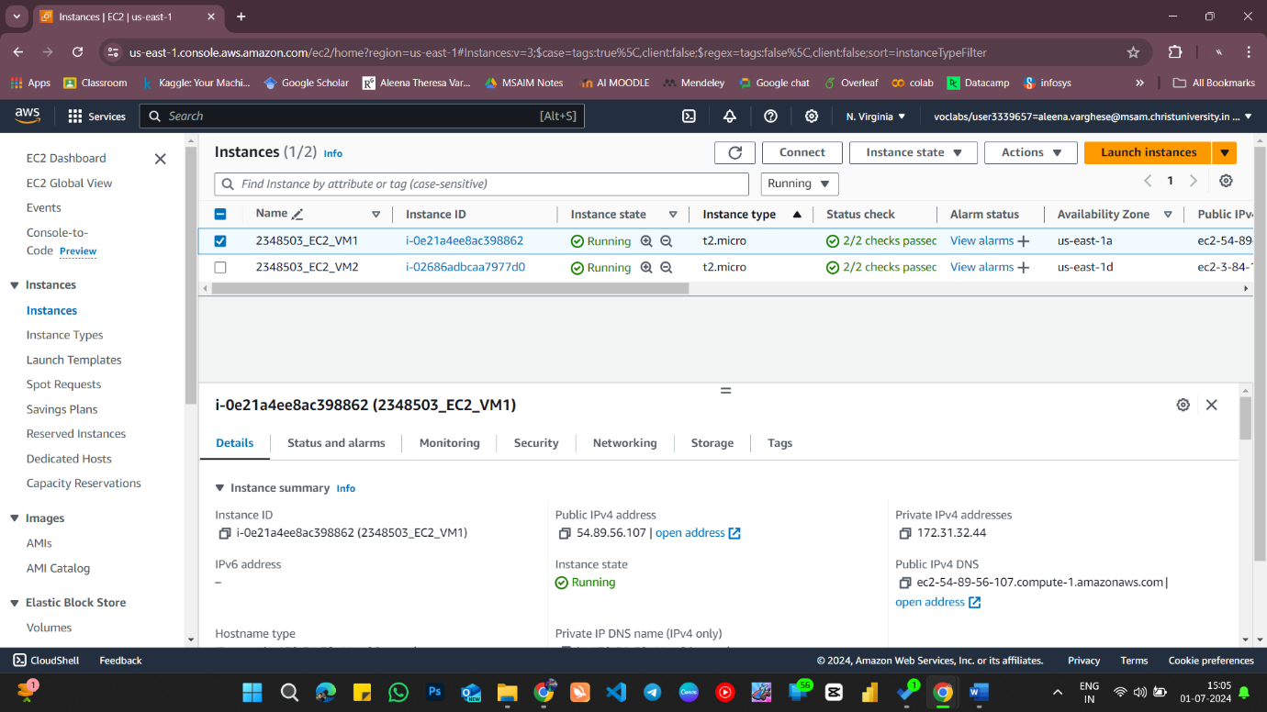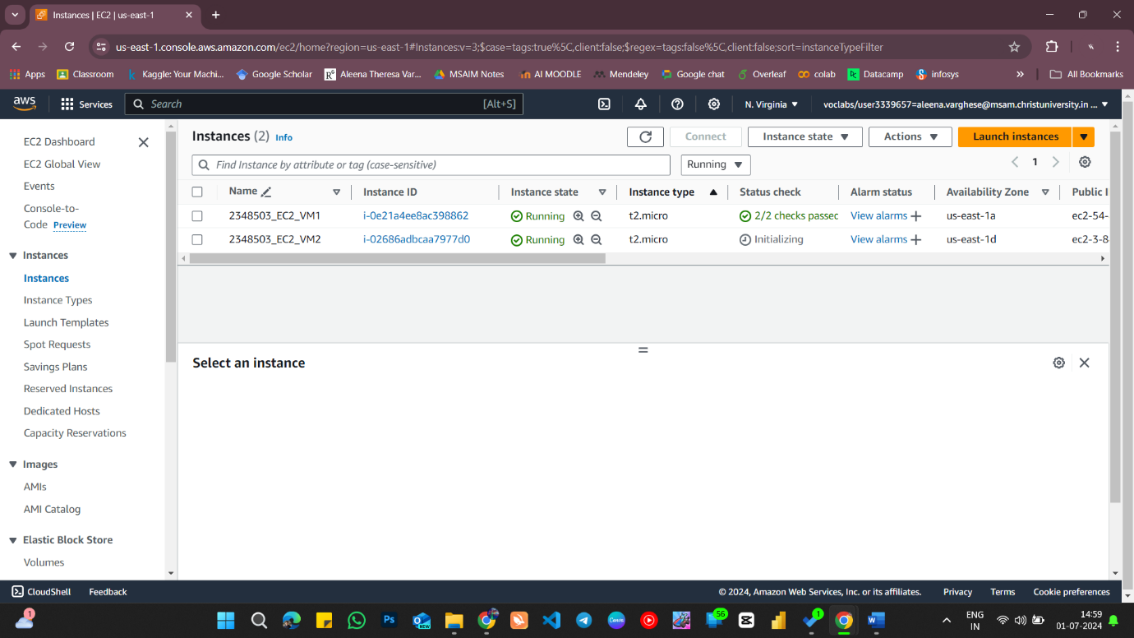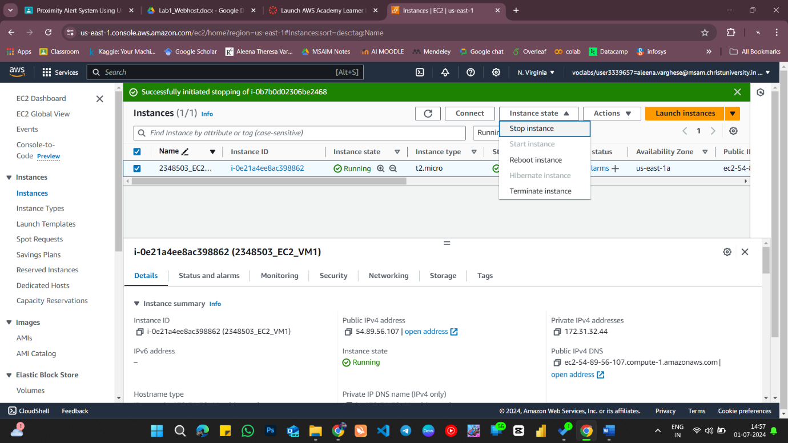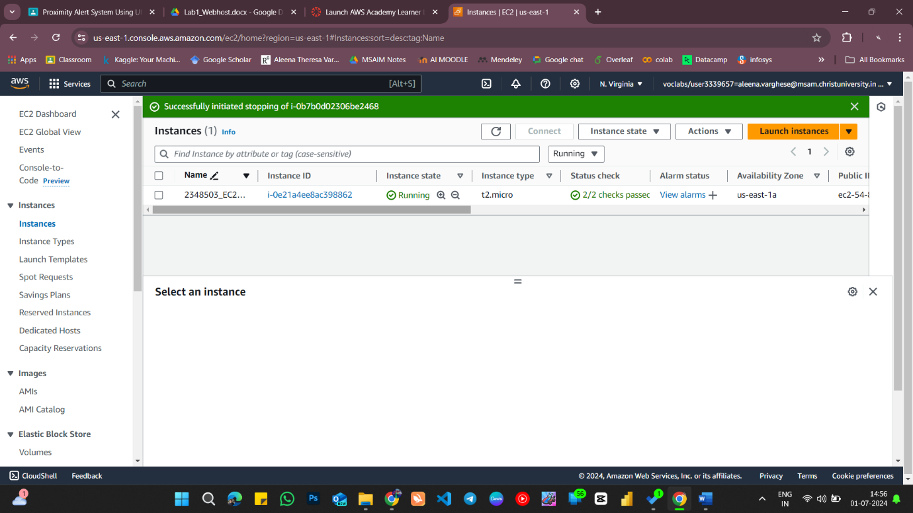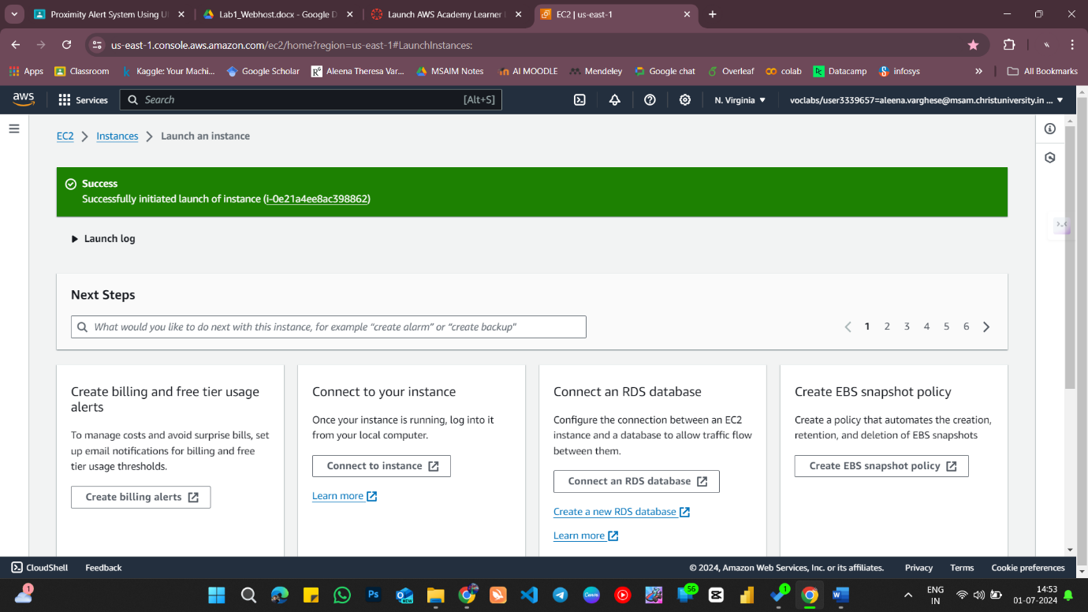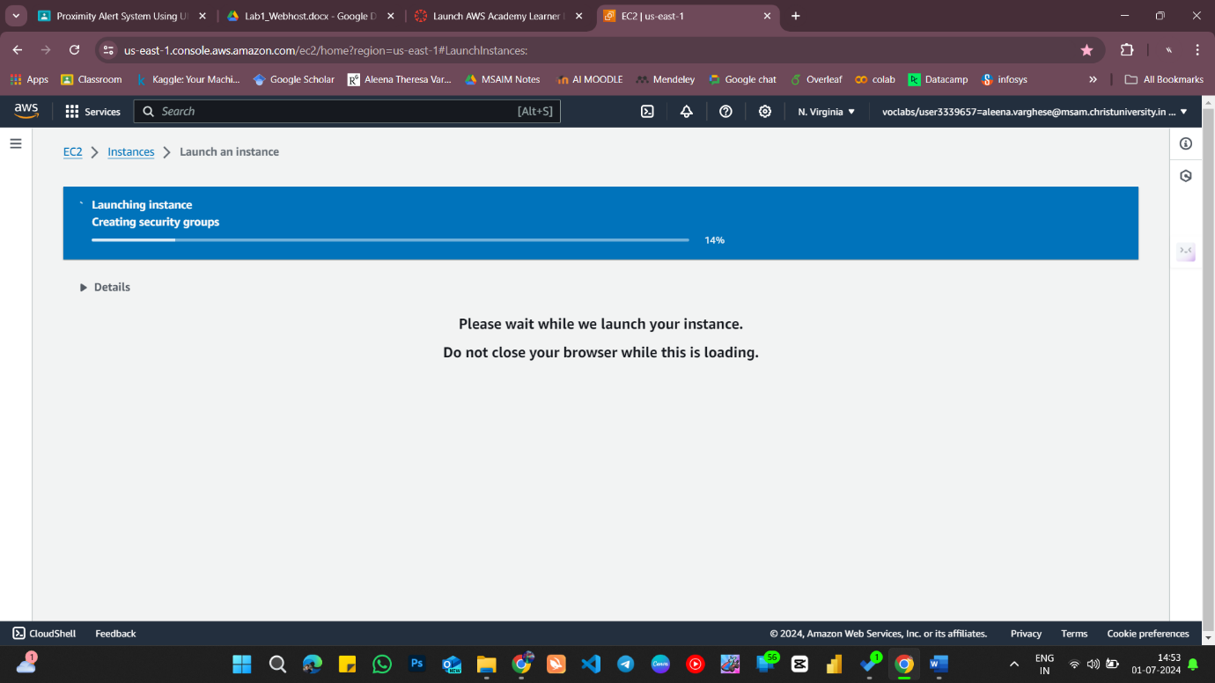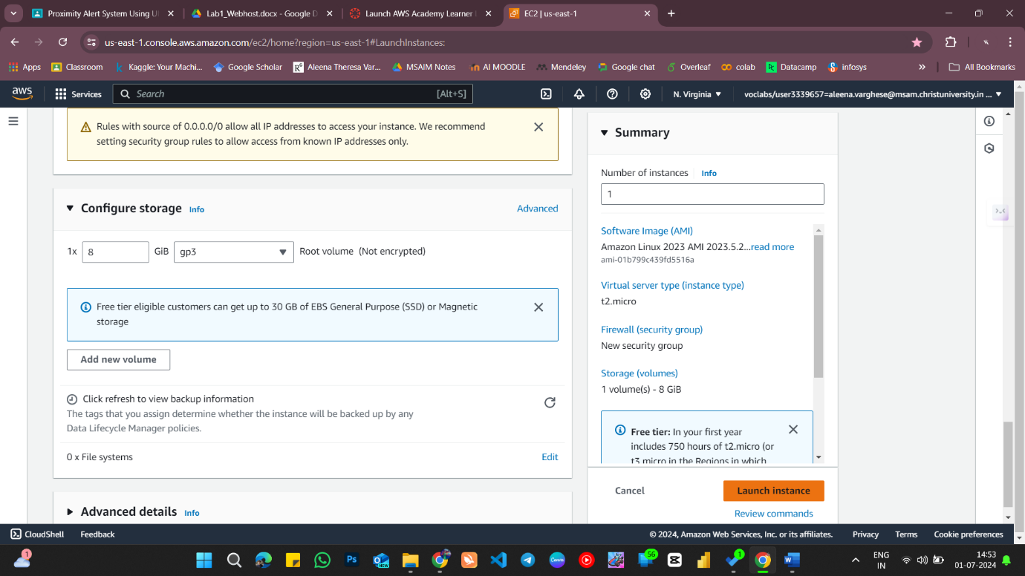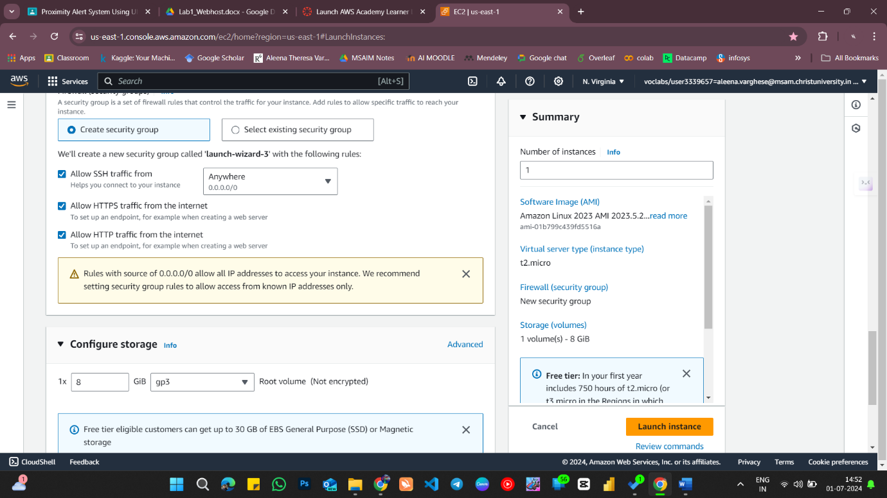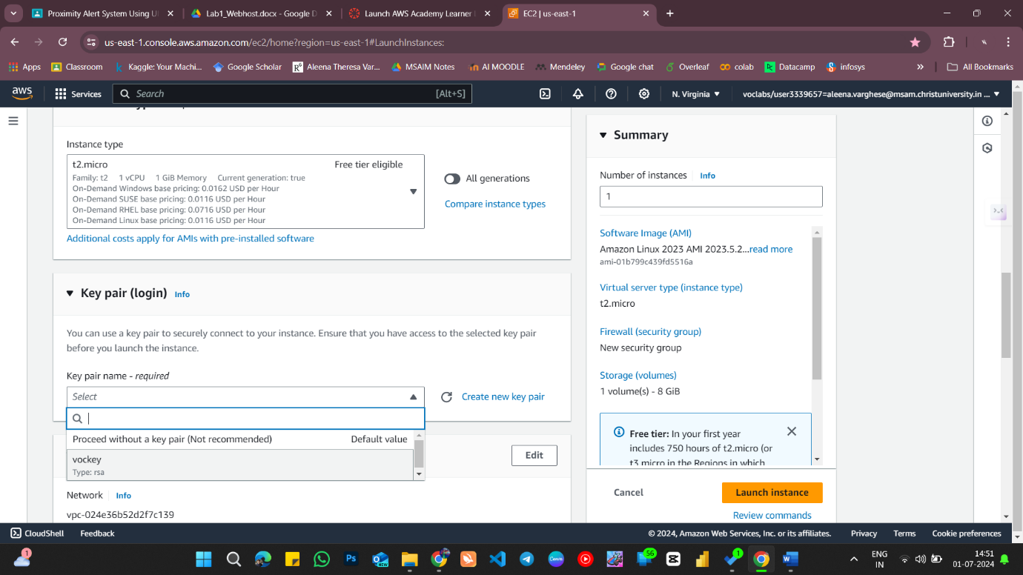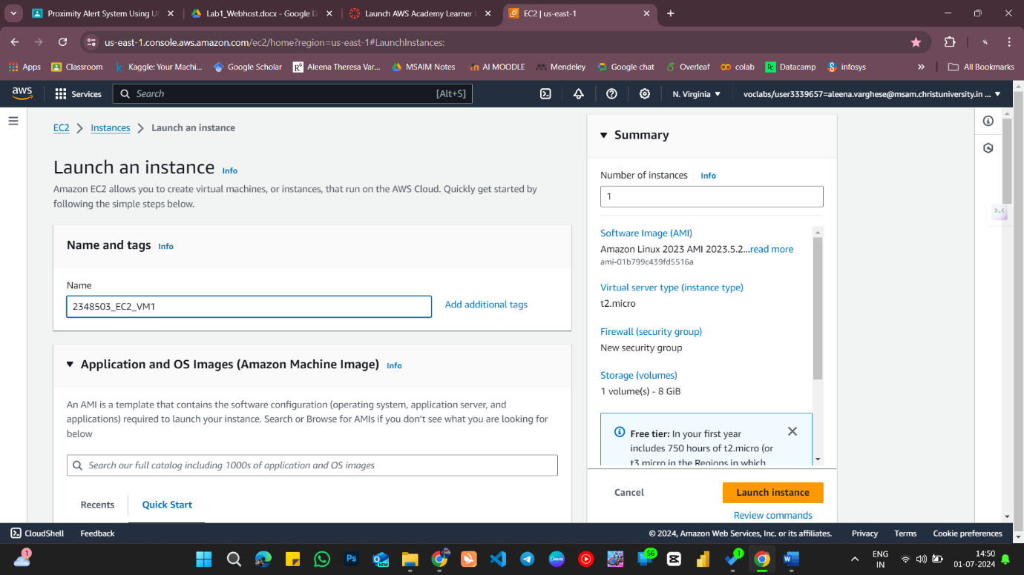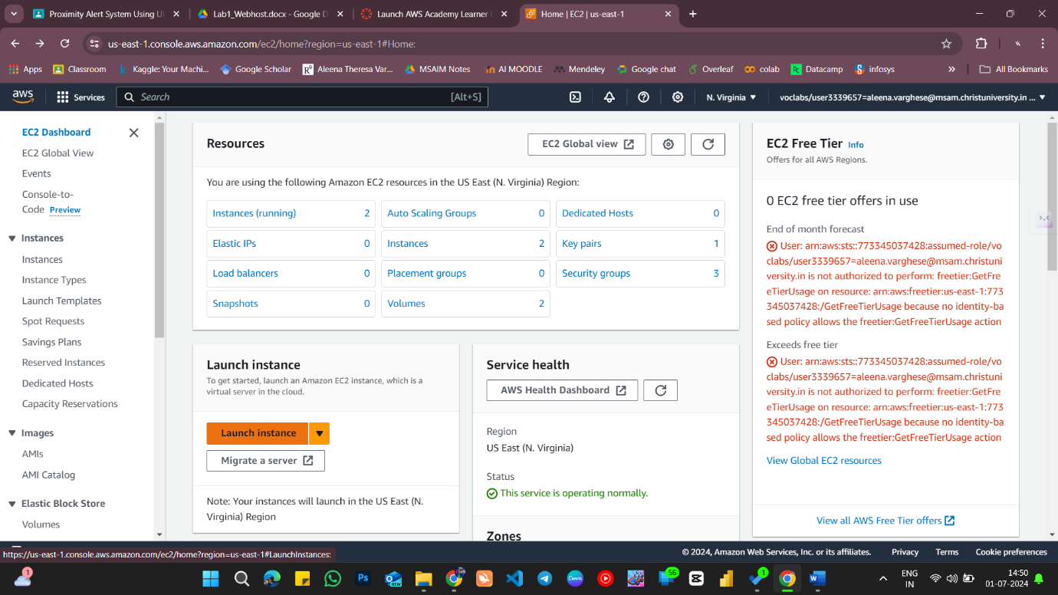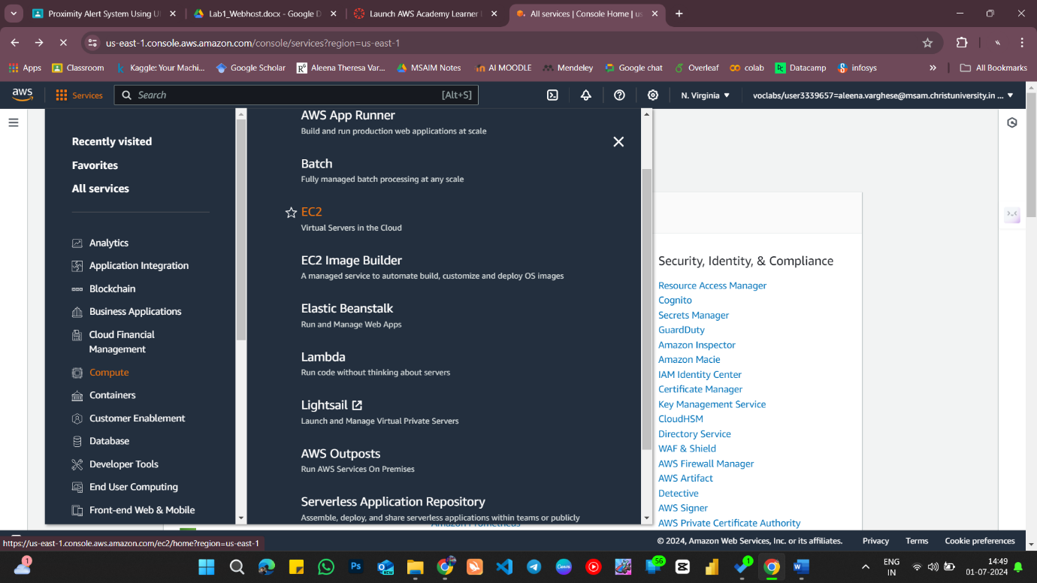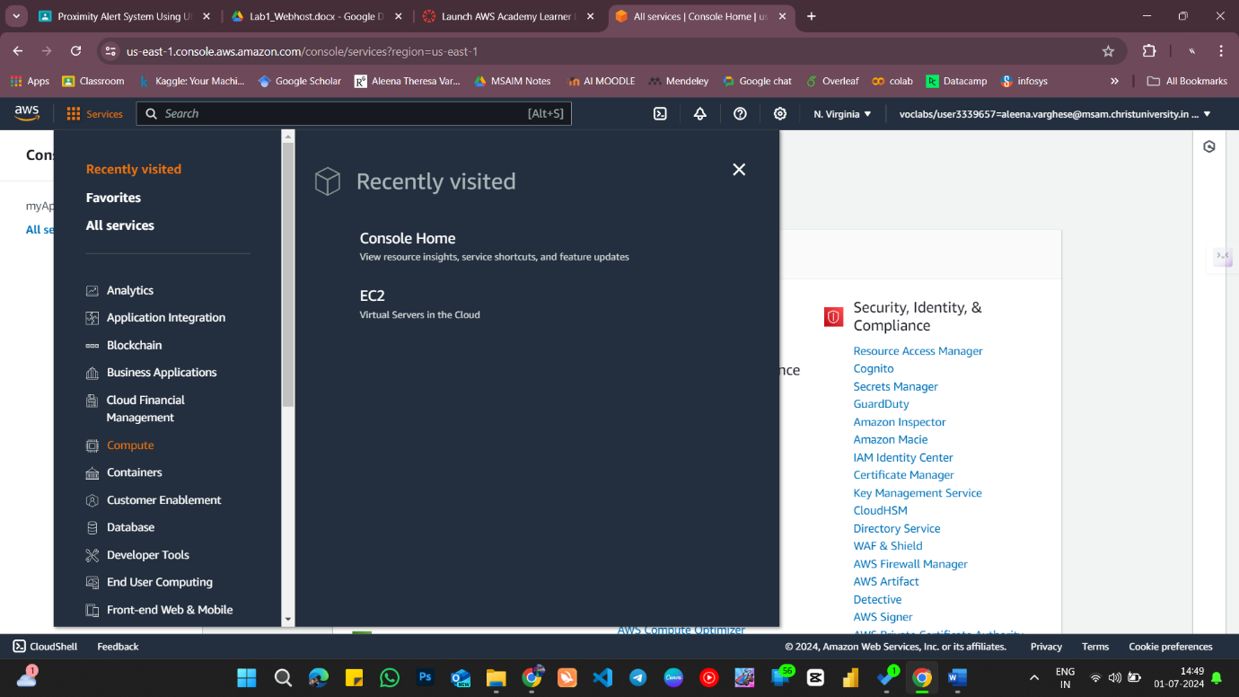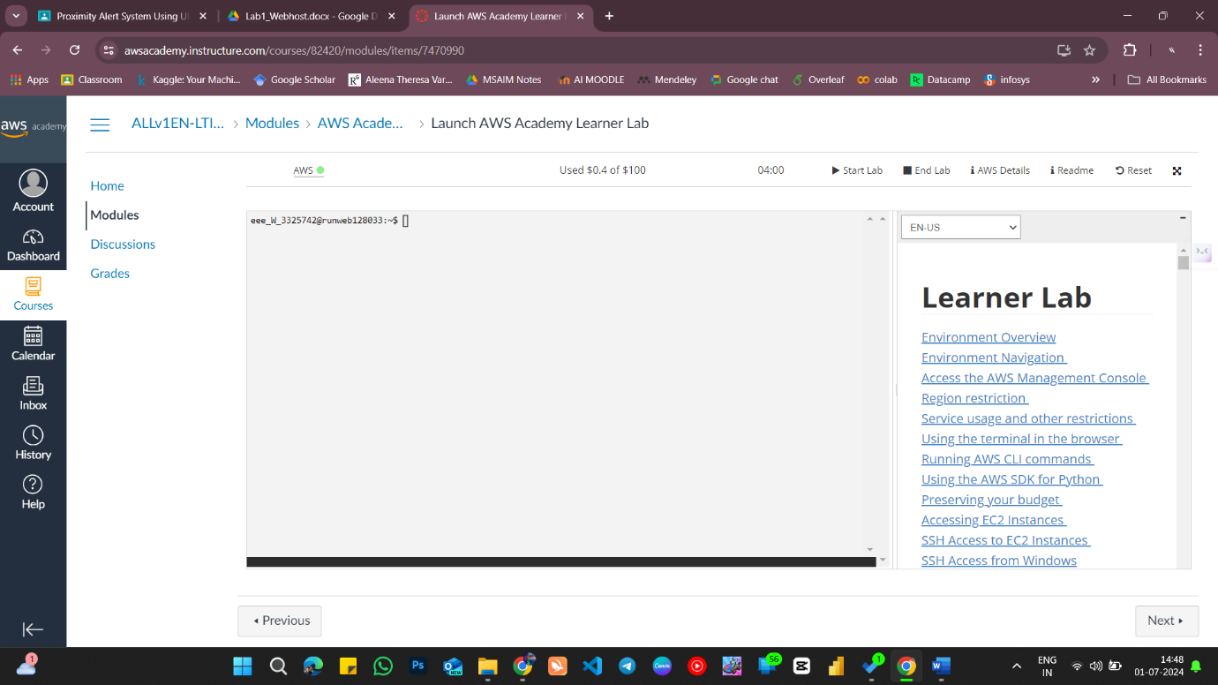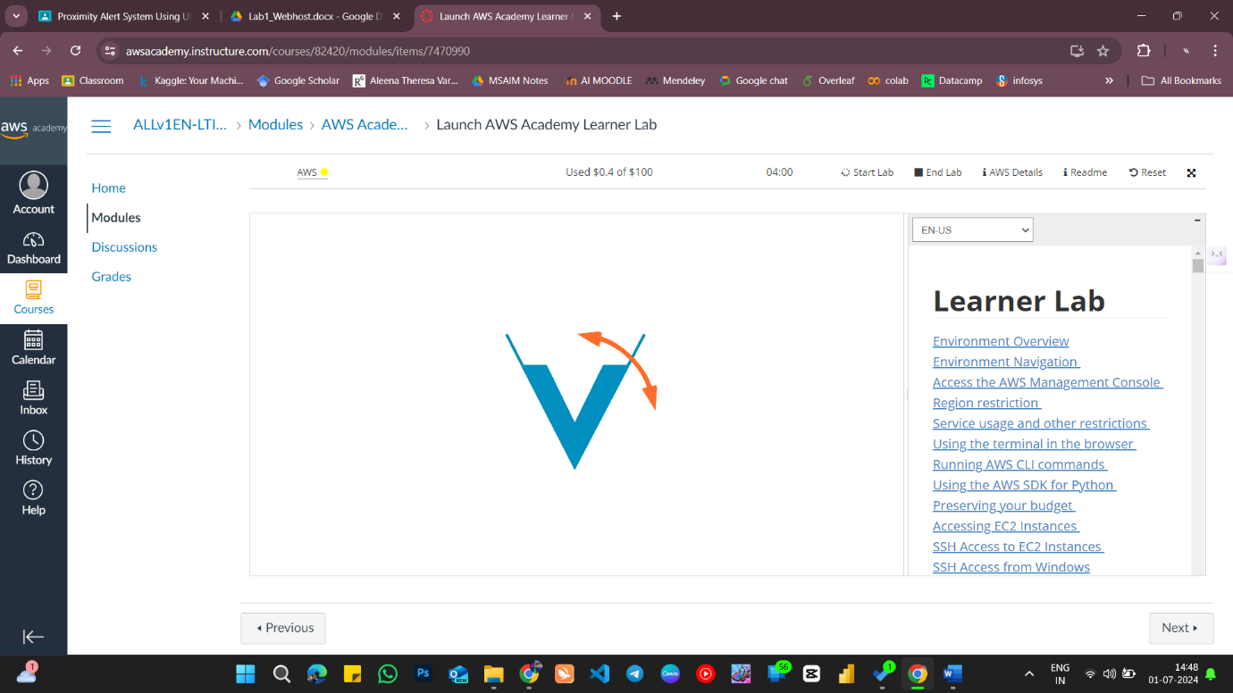

1. **Configure a Webserver on ‘Regno_EC2_VM2’ Instance and host your organizations website (Static Website) and provide access only to your machine.**

